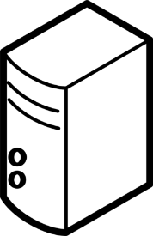

Details

This is a simple diagram of how my home network connects through Verizon’s network to a UNT system. Some assumptions:

* Assumed that the UNT system’s IP address was not cached and it needed to be looked up via root DNS server
* No shortcuts were taken going through the Verizon network

Details on hardware:

* Optical Network Terminal – Converts copper/electrical signals to fiber-optic light and vice versa
* T3 line – Common aggregation of T1 lines usually used when higher bandwidth is present
* Backbone – usually made up of a collection of fiber-optic cables allowing for very high bandwidth at one time

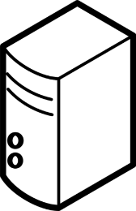

UNT Server

Root DNS Server

POP

NAP



Internet

**Verizon Network**

Ethernet

Fiber Optic

T3 Line

Backbone

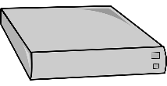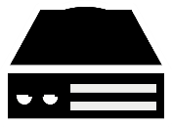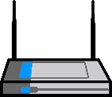

Router

One PlusOne Smartphone

Desktop PC

PS3

Optical Network Terminal

Home Network